Back to School Bash

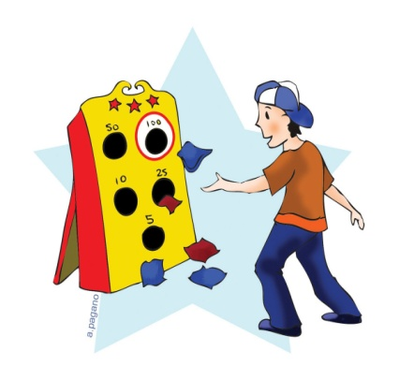
Wednesday, August 31st
5:00-7:00pm
Unadilla Elementary School
Fun
Games
Food

Come to school for a night of fun and get excited for the new school year! There will be free activity stations and giveaways, face painting, games, food & more! Free pencil boxes to the first 50 students.

Food and Game Tickets 20 for $5.00 (25 cents each)
There will be three student supply bundles raffled off at 6:30!

OUTDOOR LASER TAG, by Adrenaline Zone Paintball, will start at 4:00 and run until 8:00 pm
$3.00 a game or 2 games for $5.00

*Please note this station begins prior to and runs longer than the rest of the bash.

All Unatego Students and their families are welcome to attend!
-This event is sponsored by the Unadilla PTO.
-The event will run inside if inclement weather is forecasted!
----------------------------------------------------------------------------
*If any parents or students in Grades 6 and up would like to volunteer to help out at the bash, please contact the PTO at kgascon@unatego.stier.org or call the school at 369-6200 and speak to our new secretary, Mrs. Wright!
*Grade 3-5 Parents: Please try to attend the PTO 2016-2017 Planning Meeting on Tues., Aug. 23rd at 6:00pm in the cafeteria. We will be brainstorming & discussing plans for the upcoming year.
Thank you for supporting & being an active part of your PTO!

